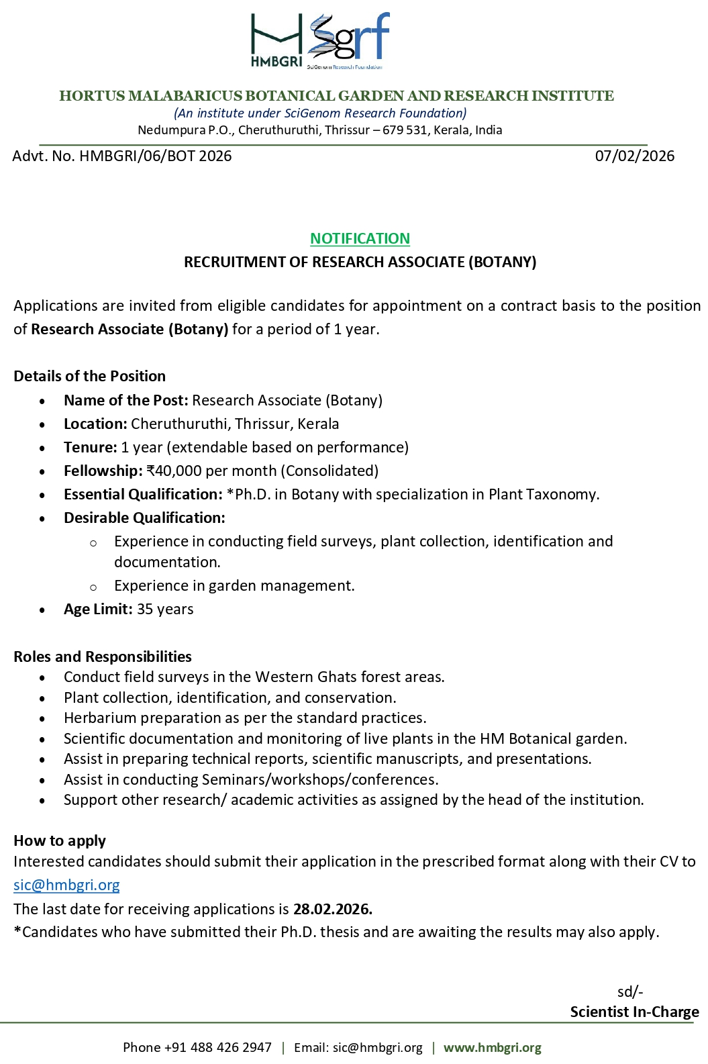

APPLICATION FORM

HORTUS MALABARICUS BOTANICAL GARDEN AND RESEARCH INSTITUTE
Cheruthuruthi, Thrissur
Photo

Application for the post of: …………………..…………………………………………..…

Advt. No.: ……………………….…………………………………………………..…………

1. | Name of the candidate  (UPPERCASE)
2. | Sex
3 | Age & Date of Birth
4 | Marital status
5 | Permanent Address
6 | Address for Communication
7 | Mobile No.
8 | Email
9 | Qualifications: -
   | Subjects | Name of School/ University/Board | Year of Passing | % of marks
  SSLC
  Higher Secondary
  Graduation
  Post-Graduation
  Ph. D
10 | Knowledge in Computer | Average/Good/Excellent
11 | Total years/months of Experience after Ph. D
12 | Do you have any published journal/ articles? If yes, attach copies.
13 | Have you attended/presented in any conferences? If yes, provide details
14 | Any other relevant information

Date: Signature:

